1. Agenda:
   1. Showcasing the partition assignment and rebalancing.
2. 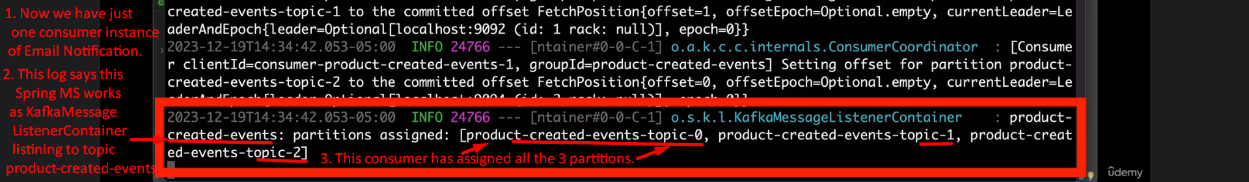
3. Jatin: I crossed check already that when a new instance is started, the partition rebalance happens and partitions are distributed among the two instances of  
   email notification consumers.  
   Same when a consumer leaves the group, rebalance occurs.